Please complete the information in the boxes below:

Title (max 128 char) | Impact of processing and matrix interaction in bioacessibility and bioavailability of phytochemicals: case study strawberry and peach
Date | Jan 15, 2016 | time | 5:30 pm GMT+1 (Vienna)
Duration | 30 min
Date for technical check | Jan 14, 2016 | time | 4 pm GMT+1 (Vienna), duration 15 min

Abstract: (aim and content of the webinar, …...) max. 2048 characters
From nutritional and functional point of view is important to understand the consequences of processing in food composition in order to select the best technological conditions required for the preservation of fruit health benefits.
Thi study was performed involving the study of pasteurization, matrix pH modification, modified atmosphere, long term storage after freezing and pasteurization of frozen fruit at different points of storage. It was possible to observe that strawberry polyphenols were more susceptible to degradation by pasteurization than peach phytochemicals, mainly due to anthocyanins. Storage under low conditions of pH (2.5) allowed to obtain higher stability of strawberries anthocyanins, while intermediate pH of about 3.0 and 3.5 were the best conditions for peach carotenoids stability and higher pH values of 4.5 led to higher content of neochlorogenic and chlorogenic acid on peach. In general, the low content of oxygen was the best condition for phytochemicals preservation, mainly 100 kPa N2 for anthocyanins and carotenoids. Long storage periods (90 d) showed a decrease on the content of all phytochemicals, at higher rate when temperatures where higher as expected. Fruit used in processing can be stored under frozen conditions, reaching periods of 360 d. This process permited easier extractability for some phytochemicals increasing them, but became more susceptible to degradation by the followed process of pasteurization.
The final step of processing encompasses the incorporation of fruit preparates in dairy matrices. Fruit polyphenols when incorporated in lactic matrices like yoghurt interacted with milk proteins namely β-lactoglobulin (β-LG) and with polysaccharides typically added to fruit formulations as stabilisers. Model mixtures pure polyphenol-protein-polyssacharide proved that pectin have a detrimental impact by decreasing significantly the phenolic content and consequently its antioxidant activity. When the model mixtures and fruit yoghurt where subjected to simulated gastrointestinal system, polyphenols revealed a higher bioaccessibility once in the presence of protein and polyssacharide. This means that food components may form complexes with polyphenols that allow protection from degradation through the digestive process making them more bioavailable.

Participants requirement profile (please specify target group)
Food technologists/scientists/engineerings working/studying in food processing area.
Speaker 1: information and foto to be sent out for announcement, max 200 words
foto 100x100px, 100kb
Maria Manuela Estevez Pintado, Ph.D.  Professor of Food Engineering  College of Biotechnology- CBQF (Chemistry and Biotechnology Centre)  Portuguese Catholic University  Rua Dr. António Bernardino de Almeida  4200-072 Porto, PORTUGAL  mpintado@porto.ucp.pt | 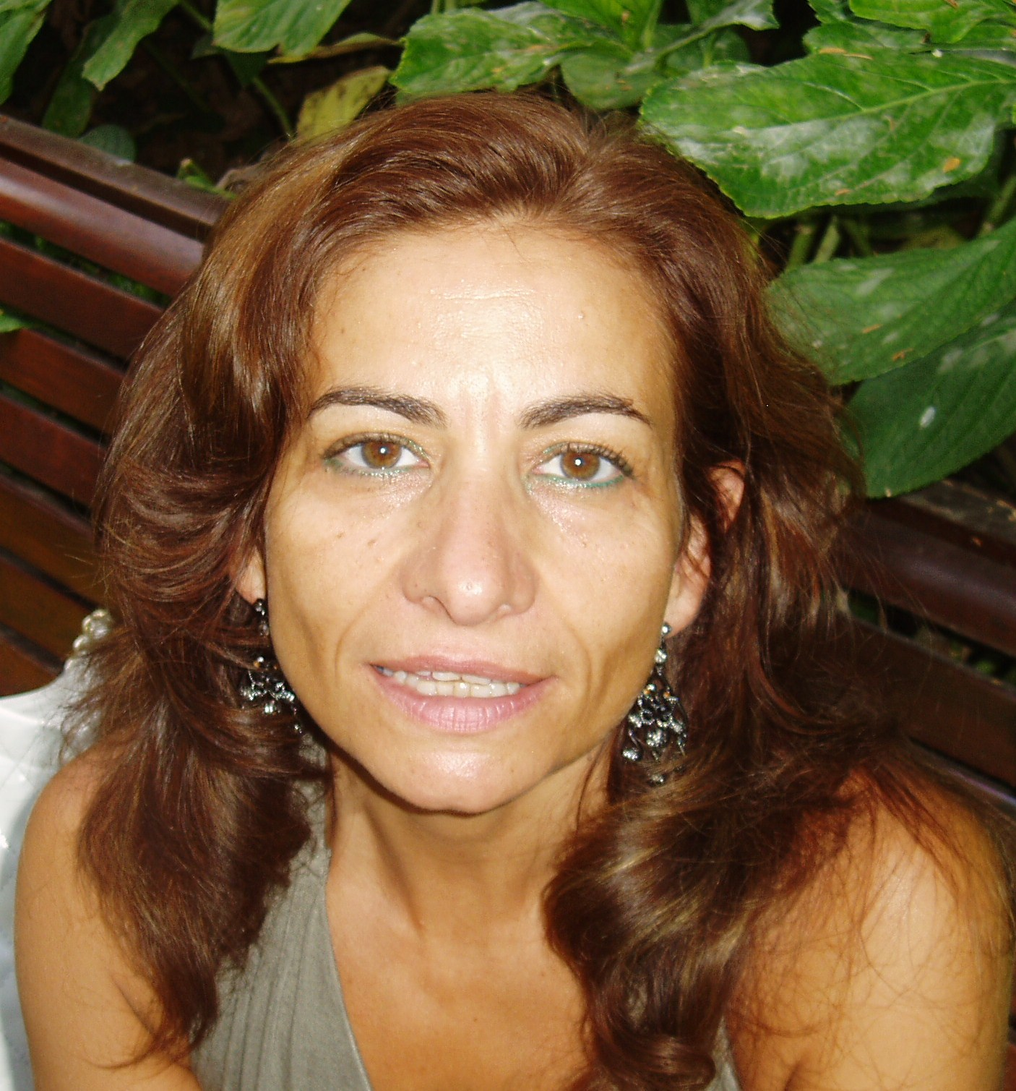
Manuela Pintado received her Ph.D. in 1999 at the Portuguese Catholic University. After her postdoctoral work at the College of Biotechnology Industry Association (AESBUC) on Force of Dairy Products, Manuela, in 2005, she joined the the College of Biotechnology of the Portuguese Catholic University where she has been teaching courses on topics in food engineering, biotechnology and biochemistry - carry out research in a range of key technologies for the production, characterization, and preservation of industrially/traditionally processed products. She is author and co-author of several papers (currently ca. 230 papers) in refereed international journals and authored 30 chapters in handbooks on these topics and creator of 9 patents. She has participated in several professional meetings and international symposia and congresses presenting about 80 invited oral communications and 60 selected oral communications and about 400 posters in National and International conferences. She supervises(ed) or co-supervises(ed) 35 MsC, 26 PhD theses and 14 Pos-doc and 18 International Sandwich PhD and 6 International Sandwich Masters. She coordinated or co-coordinated 60 externally funded (national and international funds) research and development projects including 5 EU projects from last FP7 programme.

Speaker 2: (optional)
...

Publications in Elsevier Journals:
Elsevier shows interest in your webinars and would like to support knowledge transfer activities by promoting one or two papers, you may have published in Elsevier Journals. Please name papers that are relevant to the topic of your webinar below. Elsevier will then promote them and make them freely available around the date of the webinar.
…

I agree that the presentation will be recorded
Yes No

Please correct/add polls to be sent out during or after the presentation
- Please rate the degree of interest of the topic *⁾
- Please rate the audio quality of the presentation
- Please rate the overall quality of the presentation
- Other (also questions and multiple answers can be asked):

^{*)} 1…. very interesting/good, 5…..not interesting/bad

Comments (here you can post special comments, information, etc.)

Contact details of the person in charge for organising
Manuela Pintado
mpintado@porto.ucp.pt
Please send this form with the picture to centre@food-sta.eu

